# **Magnetic Fields**

The magnetic force is *part* of the electromagnetic force: **moving charges produce a force**

* A magnet is a solid piece of metal with dipoles.
  + If you break a magnet, there is still always a north and south end.
  + (Opposites attract)
  + A magnetic dipole field is like an electric dipole: the field lines are the same

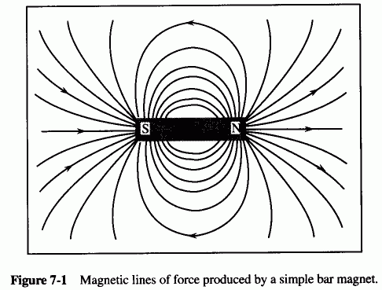

* + In addition, dipoles have a torque and/or net force in a magnetic field, just like with charges in electric fields
* The field lines of a magnetic field are **always closed!!** (the field lines go through the magnet)
* A compass is just a piece of metal that becomes **magnetized** (the dipoles align temporarily)
  + Magnets will only stick to metal that can be magnetized. They won’t stick to stainless steel because there’s no dipoles that will align
 $\vec{F_{mag}}=q\vec{v}×\vec{B}$

 + The force on a magnet depends on the charge, velocity, and the magnetic “field” $B$
  + $B$**is always perpendicular to the velocity and to the force**
    - (use the right-hand rule to find the force of the force)

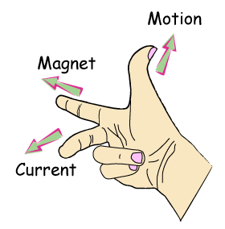

* + (1 Tesla is a really big field)
* There can also be circular orbits in magnetic fields:
  + Orbit when $F_{centrepital }=F_{magnetic}$.
  + This occurs when $F=\frac{mv^{2}}{R}=qvB$
  + So $r=\frac{mv}{qB}$
* Charges will always be pushed perpendicular to the field!
* Can’t accelerate a particle with a static magnetic field!!! (can only rotate it)

## **Magnetic Fields Due to Current**

* $B=\frac{I}{2πμ_{0}r}$ (like a line charge) where $μ_{0}=4π⋅10^{7}\frac{H}{m}$ is the permeability
* A current in a circle (circular wire) produces a *dipole field* like a bar magnet
  + circles of charge, perpendicular to the wire
  + Also a coil (solenoid) produces a dipole field
  + This allows us to turn on/off magnets!

## **Magnetic Force on A Wire (with a current)**

* Use the right-hand rule to determine which way the particles will pull the wire (it’ll bend to the force)
* $\vec{F}=I\vec{L}×\vec{B}$ (just derived using $v=v_{drift}$)
* direction of field along a wire with a current: use the “second-right-hand-rule”
  + point your thumb in the direction of the current and the rest of the fingers curl to the field lines
* Wires that have the same current attract and wires that have opposite currents repel (unusual!! but just because of the way they act in the magnetic fields)
* Application: electromotor. However, must change the polarity on the magnets at every half-turn to keep it from stopping (use a brush that is connected to two plates: pos/neg)
* Closed Loops of current:
  + torque the loop around until it is perpendicular to the magnetic field. Then all the forces cancel out
  + Rotation force is related to the magnitude of the area: more area = stronger force
  + this is the definition of a magnetic dipole (because current must be moving!!)
    - magnetic dipole moment: $\vec{m}=I⋅\vec{A}$

## **Origin of the Magnetic Field**

* Every atom is a dipole: electrons move around the proton and are rotating
* Some of these atoms cancel, but when they don’t the material is magnetic
* In iron, these dipoles are randomly oriented, but then orient when in the presence of a magnetic field
  + some materials do the opposite: repel from magnets (like graphite)
  + Based on $B=μ_{0}μ_{r}H$ (H is the magnetic field; B is the flux)
  + $μ_{r}$ is a material constant. It is always greater than (or equal to) 0
    - 1 :: no effect from magnets
    - >1 :: attracted to magnets (paramagnetic)
    - <1 :: repelled from magnets (diamagnetic)
    - >>>1 :: ferromagnetic (really strongly attracted to magnets like iron)